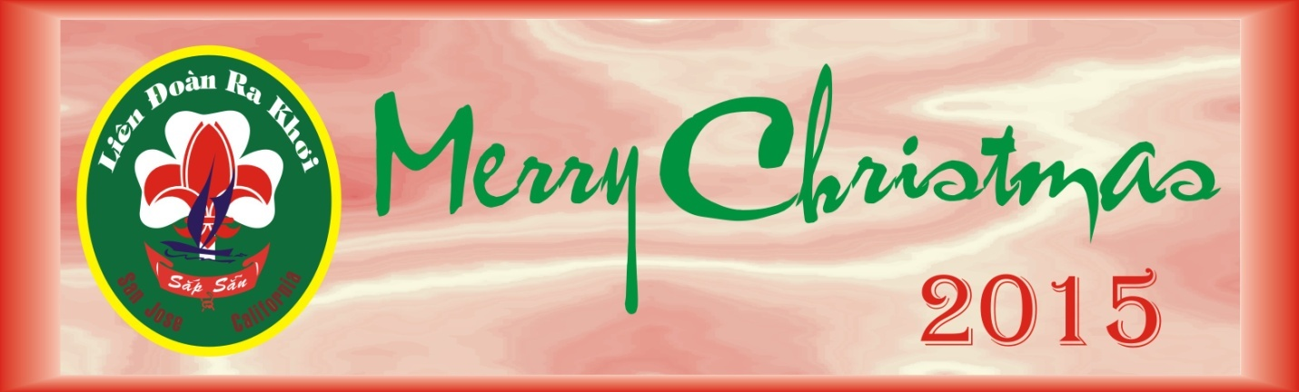

Chương Trình - Program
LĐRK Christmas Gala - Dec. 20 2015

3:00PM - 5:00PM: Setup - All Hands
- Stage Decoration, Sound & Light Sytems: Thanh Đoàn, Thân
- Bàn ăn - Dining Table Decoration: Thiếu Nữ & Thiếu Nam

5:30PM: Tiếp Tân - Reception (Chim Non)

6:00PM - 7:00PM: Dinner (Potluck by Phụ Huynh)

7:00PM: Opening
- Slide show (Thủy)
- GS Silver Award COH (Trinh & Như)
- Bài Khai Mạc - Opening Speech (Trinh)
- Cảm tưởng Phụ Huynh -Parents Speech (chị Nhi)
- Văn Nghệ - Entainterment: All Scout Units
- Khiêu vũ - Dancing (Music by Thanh Đoàn, Chuyên)

9:30PM - 10:00PM: Bế mạc - Closing -- Dọn dẹp - Clean up.

Have a safe trip home!

