https://www.sierraattahoe.com/event/scouts-weekend-201617/

Scout's Weekend
March 4, 2017 - March 5, 2017
All day event
Ryan Parker
rparker@sierraattahoe.com
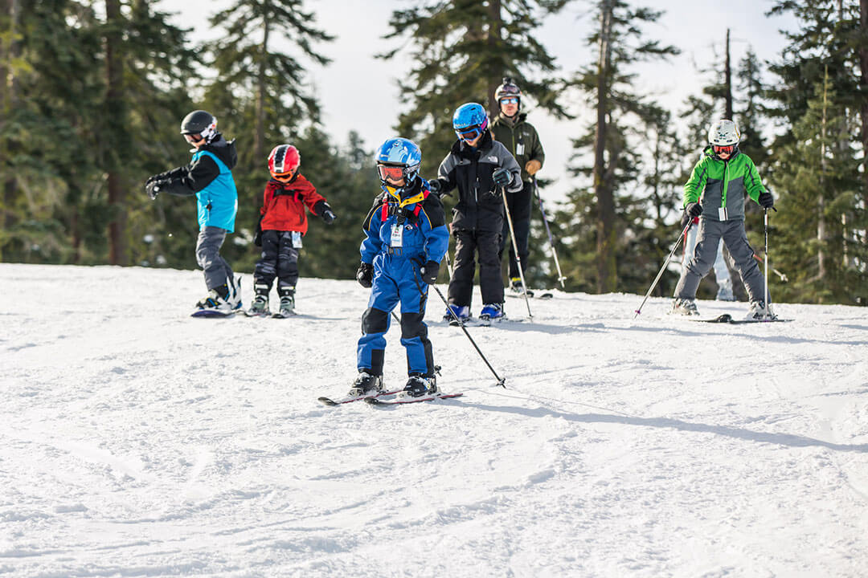
Classes will be available for Boy Scouts to earn a SNOW SPORTS Merit Badge!
Special Scout Lift Ticket Rates:
Scouts (ages 13-22). . . . . . . . . . $60
Scouts (under 13). . . . . . . . . . . . $26
Chaperones (ages 23 +). . . . . . . .$71
Discount Rentals Available (by RSVP Only)
All Boy Scouts, Girl Scouts and Cub Scouts are welcome to visit Sierra on Scout Weekend (March 4-5) to ski and snowboard at a discounted group rate. Please bring proof of membership to the Season Pass Office on March 4th and 5th to purchase your discounted tickets.
If you would like to earn the SNOW SPORTS Merit Badge, please RSVP by February 20th to:
Ryan Parker
rparker@sierraattahoe.com
530-543-3134
**Space is limited to 40 Scouts each day who need a Merit Badge Counselor.**
Unicorns, Rainbows and Big Dump Alerts In your inbox

